**KINGDOM OF CAMBODIA**

**NATION RELIGION KING**

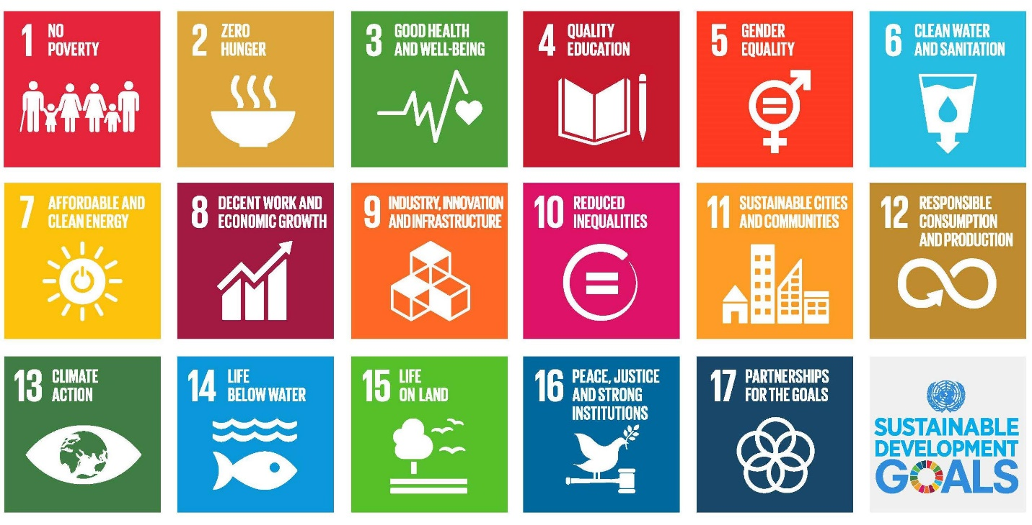

**Cambodia SDG 3 and SDG 2**

**for 2030 Agenda**

The SDGs underpin the wider Sustainable Development Agenda, adopted by the United Nations General Assembly’s 2015 session, and herald new priorities and thinking on global development needs and directions. Foremost, the SDGs recognize the twin global priorities of delivering environmental sustainability (and specifically the threat posed by climate change) and the ongoing priority of eradicating poverty. They are also more expansive, running to 17 goals and 169 targets (compared to the MDG’s 8 goals and 48 targets), and are markedly more ambitious by seeking absolute reductions and strict equalities while the previous Millennium Development Goals (MDGs) has 8 goals and 48 targets. Crucially, the SDGs aim to be transformative toward sustainable development for all countries, offering both a guide to policy choices and a means of checking national progress. They explicitly recognize the importance of equity within and between countries, the universality of human needs and rights, and the interconnectedness of the development challenge. The 17 goals are clustered under 5 themes – the so- called 5 Ps - prosperity, people, planet, peace and partnership – represent a networked whole.

**CSDG 3: Ensure healthy lives and promote well-being for all ages**

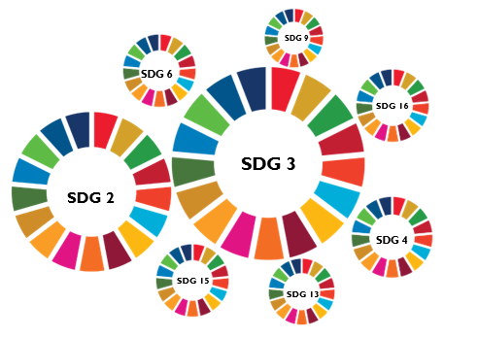

**CSDG 2: End Hunger, Achieve Food Security and Improved Nutrition and**

**Promote Sustainable Agriculture**

**Interconnection SDGs 2 to SDG 3**

**SDG 6**

Cambodia SDG 2 (CSDG 2) and SDG 3 (CSDG 3) are standalone goals on health, and zero hunger achieving the 2030 Agenda that require an integrated effort. Health and food security issues are interwoven throughout the 2030 Agenda. More than 50 SDG indicators are health-related. SDG 3 is connected with SDGs 2 and others SDGs 4, 6, 7, 9, 13, 15 and 16. Taking an integrated approach to SDG 2 and SDG 3 requires addressing inequalities.

|  |  |  |  |  |  |  |  |
| --- | --- | --- | --- | --- | --- | --- | --- |
|  | | **Action Plan for CSDG 2 and CSDG 3** | | | | | |
| Goals | Target (Output) | | Activities (Input) | Methods and Stakeholders | Data Source | Monitoring and Evaluation | Budget |
| CSDG 2 | 2.2 By 2030, end all forms of malnutrition, and food insecurity including achieving, by 2025, the internationally agreed targets on stunting and wasting in children under 5 years of age and address the nutritional needs of adolescent girls, pregnant and lacing women and older persons. | | -Improve nutrition  and promote balanced diets  -Enhance food security produce through crop and food production process | -Intensified efforts are needed to implement and scale up interventions to improve access to safe, nutritious  and sufficient food for all.  -Need support from related stakeholders such as MOA, MOE, and MOI  -Apply remote sensing to detect health-care center, agriculture farming, and resident places | -WHO database  -OpenDevelopment database  -MOH database  -Sentinel dataset | Number of children whose  weight for height z-score is  two or more standard  deviations (SD) below the  median weight for height  of a reference population | WHO, USAID and, MOE, MOA, and National Bank |
| 2.3 By 2030, double the agricultural productivity and incomes of small-scale food producers, in particular women, indigenous peoples, family farmers, pastoralists and fishers, including through secure and equal access to land, other productive resources and inputs, knowledge, financial services, markets and opportunities for value addition and non-farm employment | | -Enhance soil health  and restore land  -Mainstream biodiversity conservation and  protect ecosystem functions  -Reduce losses, encourage reuse and recycle,  and promote sustainable consumption  -Adapt and improve  investment and finance | Attention should be given specifically to increasing the agricultural productivity and incomes of small-scale  food producers, implementing sustainable agricultural practices, and ensuring the proper functioning of  markets, for example, by correcting and preventing trade restrictions and distortions in world agricultural  markets in order to limit extreme food price volatility.  Need support from related stakeholders such as MOA, MOE, and MOI  -Apply GIS remote sensing with machine learning, deep learning, IoT to generate smart farming and produce better crop production. | -MOE database  -MOA database  -MODIS dataset  -Sentinel dataset | Total value of agricultural  production (farming,  livestock production and  fisheries) in reporting year |  |
| 2.4 By 2030, ensure sustainable food production systems and implement resilient agricultural practices that increase productivity and production, that help maintain ecosystems, that strengthen capacity for adaption to climate change, extreme weather, drought, flooding and other disasters and that progressively improve land and soil quality. | | -Strengthen  innovation systems  -Address and adapt  to climate change  -Strengthen ecosystem resilience | -Small-scale food producers must receive support to improve their agricultural productivity so that they can strengthen their resilience and adaptive capacity  -Need support from related stakeholders such as MOA, MOE, and MOI  -Apply GIS remote sensing with machine learning, deep learning, IoT to generate sustainable smart agriculture and ecosystem | -MOE database  -MOA database  -MODIS dataset  -Sentinel dataset | Total Value of agricultural  production ($) in the  reporting year |  |
| CSDG 3 | **3.3**By 2030, end the epidemics of AIDS, tuberculosis, malaria and neglected tropical diseases and combat hepatitis, water-borne diseases and other communicable diseases, and Covid-19 | | Improve health care system and human resource in medical fields. More specialty improves AI applications and remote sensing to support health care systems | -Improve quality of education on communicable disease  -Need support from related stakeholders such as MOH, and MOI  -Apply human mobility data and health information system for tracking patient | -HIS 3.0 web-based system  -MOH database  -Human mobility data (GPS) | Monitoring number of effected people | WHO, USAID and, MOH, and National Bank |
| **3.4**By 2030, reduce by one third premature mortality from non-communicable diseases through prevention and treatment and promote mental health and well-being. | | Improve health care system and human resource in medical fields. More specialty improves AI applications and remote sensing to support health care systems | -Improve quality of education on non-communicable disease  -Need support from related stakeholders such as MOH, and MOI  -Apply human mobility data and health information system for tracking patient | -HIS 3.0 web-based system  -MOH database  -Human mobility data (GPS) | Number of deaths  between ages 30 and 70  years in the year due to  cardiovascular, cancers,  diabetes, or chronic  respiratory diseases in the  year |  |
| **3.6** By 2020, halve the number of global deaths and injuries from road traffic accidents. | | Strengthen implementation  of traffic law and infrastructures | Need support from related stakeholders such as MOH, and MOI  -Apply human mobility data, CCTV, GPS, UAV, and health information system for tracking patient | -MOI database  -CCTV  -UAV (proposed for JICA support) | Number of deaths  population due to road  accident in the reporting  year |  |
| **3.8** Achieve universal health coverage, including financial risk protection, access to quality essential health-care services and access to safe, effective, quality and affordable essential medicines and vaccines for all. | | Boost effective and sustainable primary health care for achieving the health-related SDG targets and progress on the other accelerator themes. | Strengthen sustainable financing enables countries to reduce unmet need for services and financial hardship arising from out-of-pocket payments by establishing and progressively strengthening systems to mobilize adequate resources for health and to spend them better to deliver more health for the money. | HIS 3.0 web-based system  -MOH database  -Human mobility data (GPS)  -HEFs’ database | Number of people living  under the poverty line who  are covered by health equity funds (HEFs) in  reporting year |  |